Name :SK.Kashifa

Register no :192121135

Online voting system

Class Diagram :

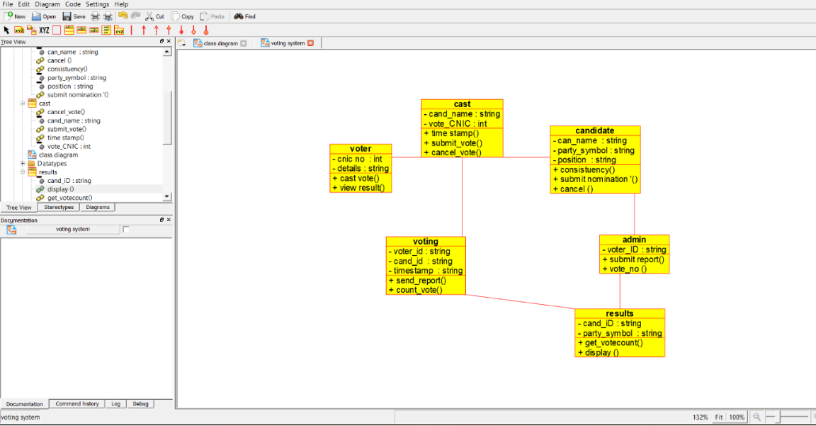

Sequence diagram :

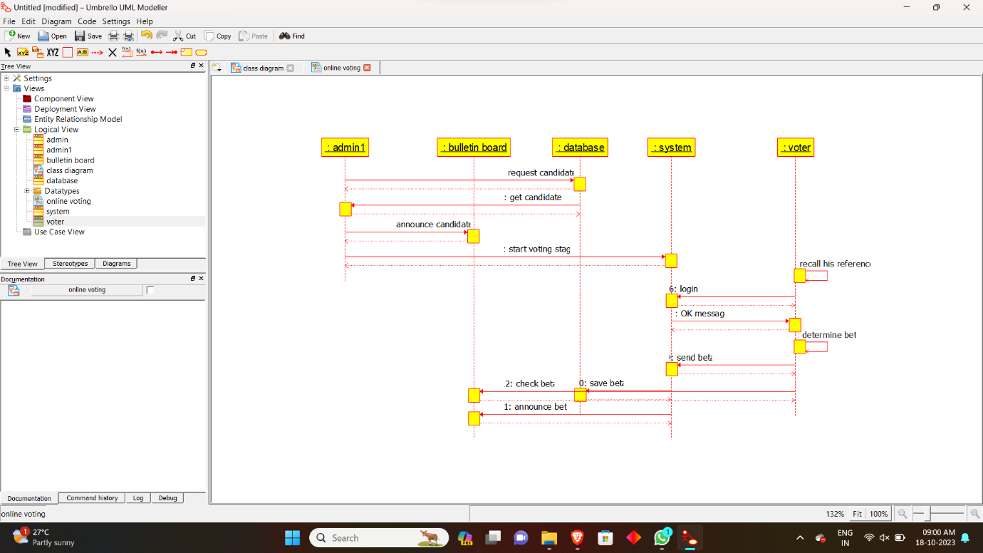

Activity diagram :

